**RESUME**

**BOGA PREETHI**

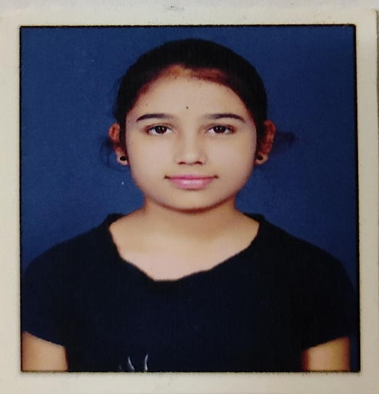

**Computer Science Engineering**

**Cell no:**9491950034

**Email ID:**preethiboga@gmail.com

**Address:**Manakondur,Karimnagar,Telangana

**OBJECTIVE**

Computer Science Engineering student at RGUKT Basar looking to gain experience and secure a responsible career opportunity.

**ACADEMICS/QUALIFICATIONS**

**2017-2018** S.S.C(class x)

Telangana State Model School

9.8CGPA

**2018-2020** P.U.C(pre-university course):M.P.C

Rajiv Gandhi University Of Knowledge Technologies-Basar

9.8CGPA

**2020-2024** C.S.E (computer science engineering) Branch

Rajiv Gandhi University Of Knowledge Technologies-Basar

9.0CGPA

**TECHNICAL SKILLS**

**Operating systems** Windows,Linux

**Programming languages** Python,C

**SOFT SKILLS**

Time management

Problem solving

Self motivated

Positive attitude

**PERSONAL PROFILE**

**Father’s name** Boga Sudharshan

**Mother’s name** Boga Kavya

**Occupation** Auto driver

**Date of birth** 3rd Jan,2003

**Address** H.no 8-50/2,Manakondur,Karimnagar(dist),Telangana,Pincode- 505505

**Contact** 9491950034

**LANGUAGE**

English

Telugu

Hindi

**STRENGTHS**

Patience

Dedicated

Determined

**EXTRA-CURRICULAR ACTIVITIES**

Playing Badminton,video games

Participated in all NSS events

Singing

**ACHIEVEMENTS**

Certificate of 2nd place in mandal

Maths forum Honor date Dec22,2018

Secured a seat in Rajiv Gandhi University Of Knowledge Technologies,Basar for 6 years integrated Education

Worked as volunteer in NSS wing

**DECLARATION**

I here by declare that above mentioned particulars are true and correct to the best of my knowledge and belief.

**Date:**10th July,2021

**Place:**Manakondur

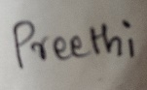

**Signature**